

AJ Chapman, Jacob Kemp-Scheider, Nuha Syed, Sam Deane, Will Bertiz

Project 3 Design Doc

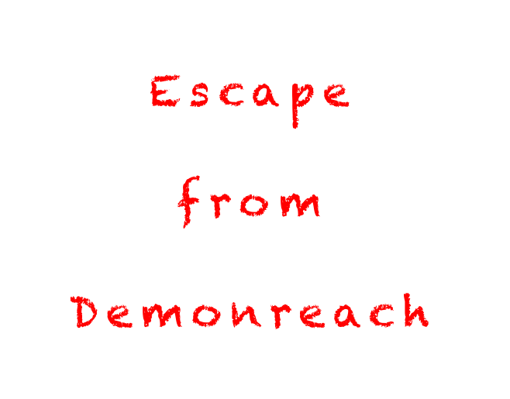

***The hunter becomes the hunted***

**Genre:**

Horror, Stealth, Supernatural, First person

**Narrative Context/Pitch:**

You are an inmate at Demonreach, a prison for monsters. When Mab casts a spell to release the inmates, you are free of your shackles, but only until Harry and the Genius Loci find you and imprison you again. Escape the wardens of Demonreach, and find your freedom once again.

Narrative context for monster getting released: “Dresden and his team try to determine who is casting the spell required to release the monsters, and should they be Outsiders, who let them into this world.”

**Objective:**

Escape Demonreach and its two wardens, Harry Dresden and the Genius Loci, Alfred. Obstacles will be in your way that you will have to overcome while avoiding both Harry and Alfred. You must collect several keys in order to open a series of doors and escape Demonreach.

**Win Condition:**

* Escape Demonreach and get to the outside world
* Don’t get caught in the process

**Obstacles to Winning:**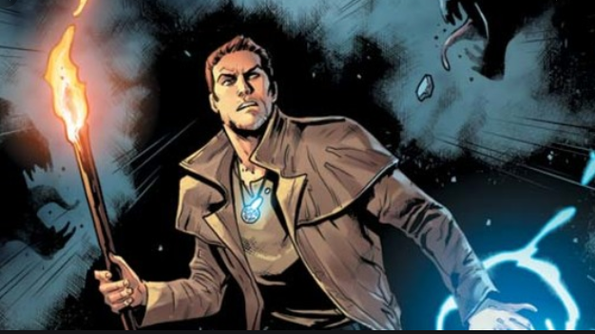

* Harry Dresden
* Genus Loci
* Demonreach Itself

**Rules/Game Logic:**

* Enemies hunt you down
  + Harry teleports to different nodes
  + Genius Loci walks around checking areas
* Don't get spotted by enemies
  + If you do you must use your shapeshifting to escape
* Player needs to find magical keys
  + Enemies alerted of presence on pickup
  + Need 4 keys
    - Enemies get angry and change behavior upon picking up all the keys
* Player needs to unlock final door to escape

**Mechanics:**

* Light
  + Night vision ability
    - Has cooldown, must be activated by player
* Audio
  + Players can hear footsteps from a warden when they are near the player. Harry and the Genius Loci have different footsteps to differentiate them.
  + Genius Loci
    - Loud Footsteps, can easily be heard by the player from a moderate distance away
    - Can be heard through walls
  + Harry
    - Much quieter, footsteps can be only be head from a short distance
* Shapeshifting
  + Player can transform into small animals for a limited time and pass through areas that the wardens cannot pass through
    - Rat

Can go into small cracks between walls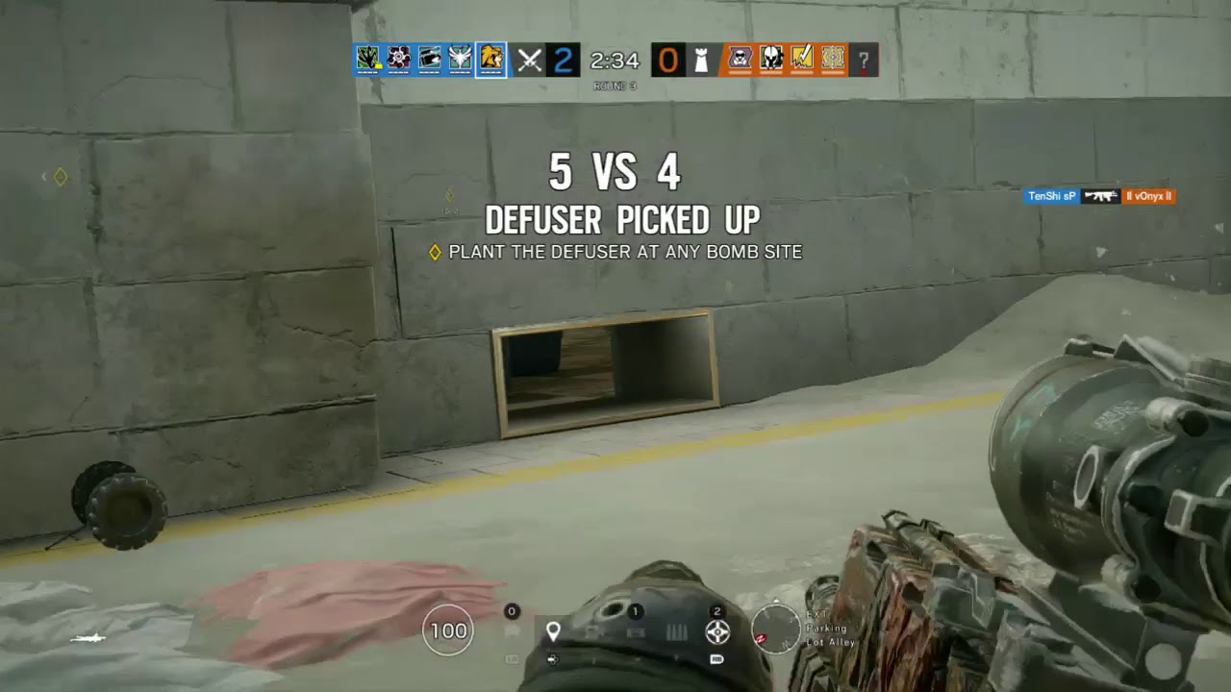

* + Similar games:
    - *Rainbow 6 Siege* (drone behavior)
* Item Collection
  + Player has to gather a collection of [magical macguffins] in order to escape and win the game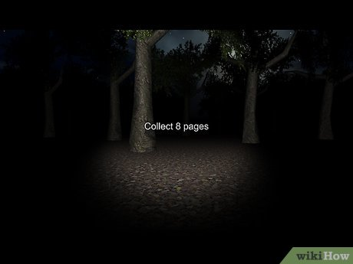
  + Similar games:
    - *Slenderman*
    - *Baldi’s Basics in Education and Learning*

**Game Objects:**

* Player - Naagloshii
  + Rat form
* Wardens
  + Harry
  + Genius Loci
* Keys

**Architecture:**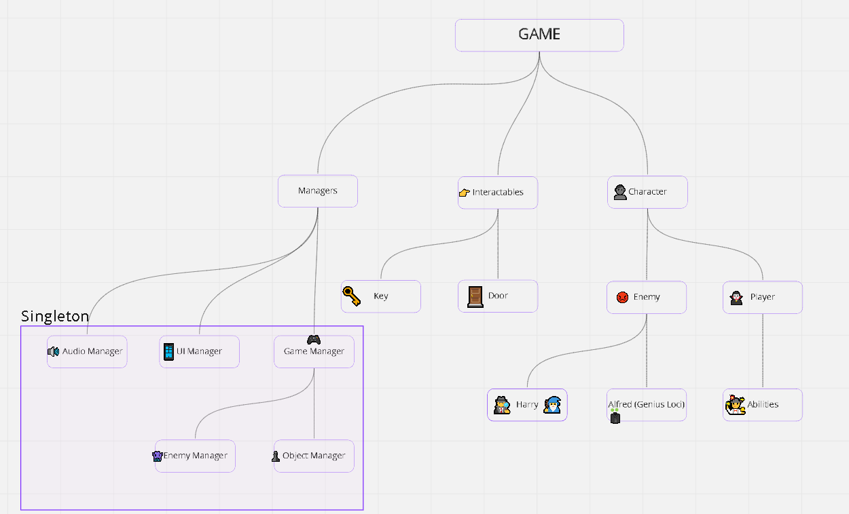

* Character Class
  + Can move themselves
  + Monster and Player inherit from this
* Enemy Class
  + Have some kind of perception to detect the player
  + Can play sound effects
  + Harry and Alfred are children of this class
  + Harry and Aflred will path from node to node around the prison
    - They will constantly be projecting a vision cone that will be their FoV
* Harry
  + Does not have an actual model
  + Audio queues will tell you when he gets closer
  + When Harry detects the player he will start making sound effects
  + Once he reaches him he will cast a spell to stop the player from moving then appear from behind and grab the player
* Alfred
  + Has a more hulking and scary model
  + Slowly moves around the prison from node to node in search of the player
  + When he finds the player he will start a charge towards them
  + If he can no longer see the player he will continue pathing towards where he last saw the player
  + Then he will look around him for the player
  + If he still can not find them he will resume pathing around
* Player Class
  + Receives input from input handler to call it’s parent's movement classes
  + Handles the activation of any player abilities (like reducing it’s collision box in the case that it’s something that transforms into a mouse)
* Input Handler
  + A static singleton that holds a data structure of “every input that is active this frame” and then any other class can see that data structure at any moment
    - Not technically efficient but easy to program
* Mostly Game Manager Update() checking these inputs and calling methods of other classes, but the option to check inputs in other classes it there if we need it
* Has helper methods which make it easier for game manager to check on the inputs (reducing the amount of visible code in Game Manager)
* **Game States Hierarchy:**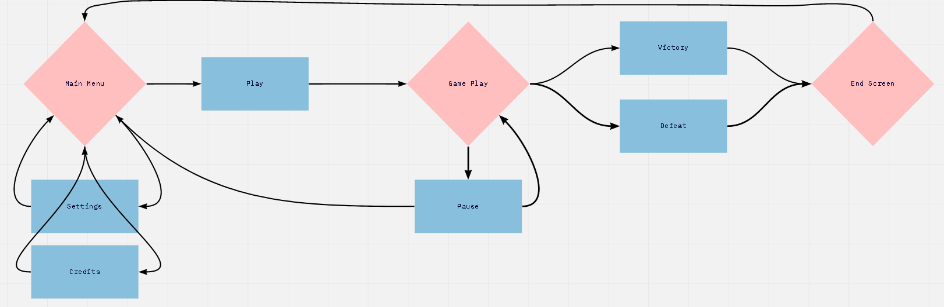

**Aesthetics:**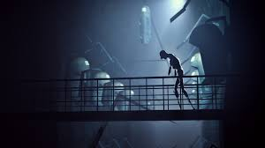

* Spooky
* Generally dark, with the exception of small candles throughout the hall
  + Also crystals along the wall
  + *Half Life 2* Citadel, but with crystals instead of mechanical pods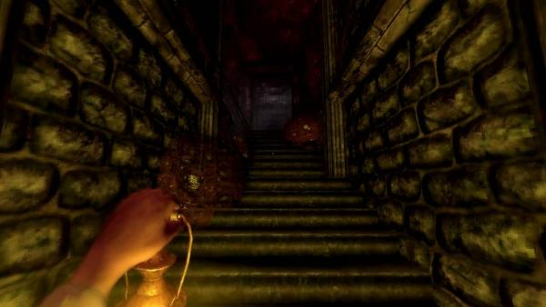
* Castle/Dungeon architecture
  + Bricks, candles, gothic style
  + *Amnesia* games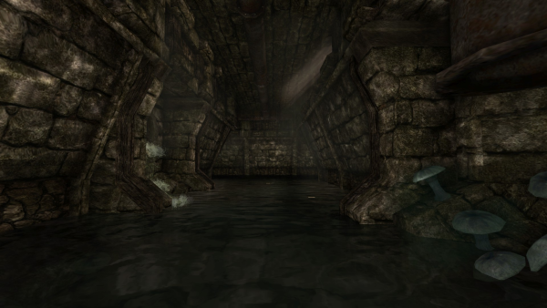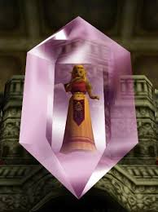
  + Hallways

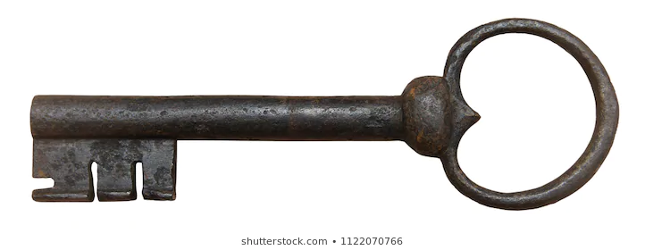

**MVP Asset Lists:**

* Below is a list for assets we’d need to make a polished Minimum VIable Product
* Art:
  + Character Models
    - Harry
    - Genius Loci
  + Object Models
    - Lighting
      * Candles
        + Wall
        + Table
        + Candle Holder (For Harry?)
    - Keys
  + Environment
    - Doors
    - Crystals
  + Textures
    - Brick Prison Walls
    - Wood
    - Metal (Candleholders and prison bars)
    - Crystal
  + UI
    - Text
    - Current Player Animal
    - Health (Blood splatters on edge of screen)
  + **Total Art Assets Count: 15 (11 Models, 4 Textures, 3 UI Elements)**
* Audio**:**
  + Player
    - Transformation
      * Into Animal
      * Into Humanoid Form
    - Footsteps
      * Player
      * Rat
    - Breathing
  + Genius Loci
    - Footsteps
      * Wandering
      * Alerted (Louder and heavier)
    - Vocal
      * Alerted
      * Spot Player
      * Lost Player Location
  + Harry
    - Footsteps
      * Wandering
      * Alerted (Louder and heavier)
    - Vocal
      * Alerted
      * Spot Player
      * Lost Player Location
  + Environment
    - Cellar/Dungeon Ambience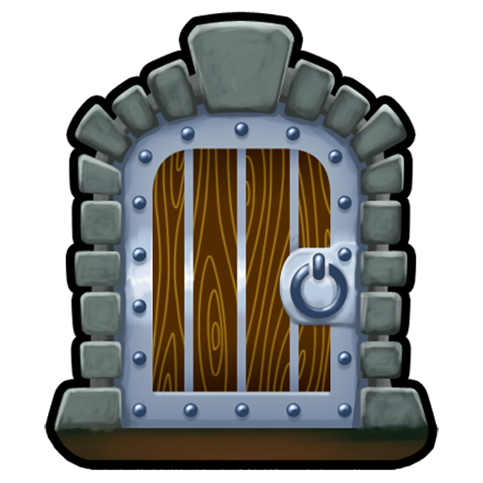
      * Water droplets(?)
    - Candles Burning
  + UI
    - Confirm
    - Back
    - Slider Tick
  + Music
    - Main Menu
    - Gameplay
      * Spotted by Warden
      * Tension (Warden is suspicious)
      * Lowered Tension (Escaped from warden)
      * Lose
      * Win
  + **Total Audio Assets Count: 26 total sounds (15 Sound FX, 2 Environment/Ambience, 3 UI, 6 Music)**